* Task 1
  + I see the Enroll Client option, but not a Quick Enroll option
  + Type in Security Answer, hit save, security answer field returns blank
* Task 2
  + In study tasks form, bullet 5, “care tads” -> “care tags”
  + Step 7, wasn’t sure what to do with Risk of HIV
* Task 3
  + Message appears in thread header, but no actual message is received
* Task 4
  + No issues
* Task 5
  + No issues
* Task 6
  + No issues
* Task 7
  + No issues
* Task 8
  + Need to click Send More Surveys before New Survey button
  + Unsure of what to do with questionnaire dropdown, only mentions sub-questionnaire
* Task 9
  + Surveys table doesn’t populate with the survey I just made
* Task 10
  + Receive error when clicking on Interventions button
  + 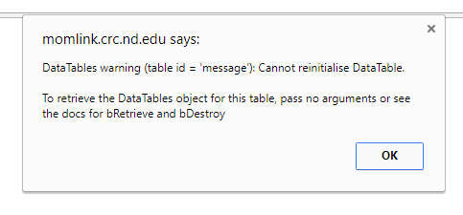
  + Still able to complete the task